**Structure document for**

**VOIS Selenium Task**

**Purpose:**

The purpose of this document is explaining the project structure and all tools and technologies that used in this project

**Project Structure:**

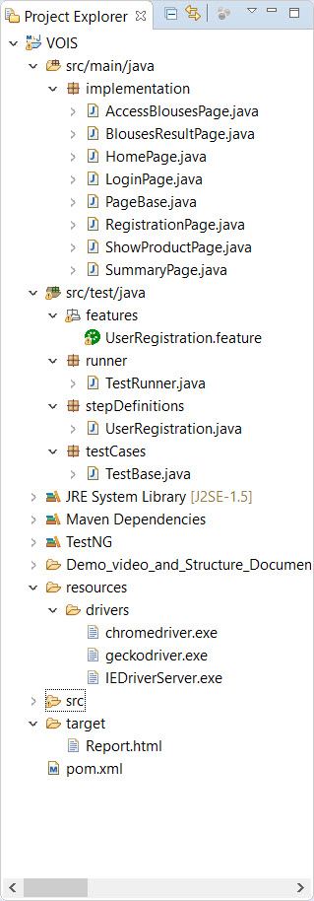The project structure is as the following:

**1- “Src > main > java” folder:**

Containing “implementation” package, this package contains implementation classes for all pages of that project, and all of them inheriting from “PageBase” class, that contains most common configurations and methods that needed at different classes that inherit from it.

**2- src > test > java**

This folder containing 4 packages:

1. **Features**: containing feature file that contains the feature, scenario and data details in format of BDD and gherkin.
2. **Runner**: containing the runner class that is the launcher of the project.
3. **Step definitions**: containing the main class that translates scenario in feature file into executable code and methods.
4. **Test cases**: containing the test base class that contains Before & After test code.

**3- resources:** containing drivers needed to launch the test on the browser, it’s containing drivers for google chrome, firefox, and internet explorer browsers.

**4- target:** contains report that automatically produced with each operation, you can find its settings at src > test > java > TestRunner.

**5- pom.xml:** containing all project dependencies.

**Used tools and technologies:**

* Eclipse IDE
* Selenium java
* Maven
* Testng
* Cucumber
* Gherkin
* Google chrome browser and driver